CREDIT PROCEDURES

CREDIT=MONEY DUE A CUSTOMER FOR THE FOLLOWING REASONS:
- INFERIOR QUALITY PER CUSTOMER REJECTION
- NOT WHAT THEY ASKED FOR
a. Salesman wrote wrong part
b. Shipping picked wrong part
- WRONG GRAPHICS
a. Salesman didn’t get art approval
b. Salesman chose wrong art
4. DAMAGED UPON RECEIPT
a. Due to inadequate packaging
b. Due to shipper handling
5. CUSTOMER SAYS HE DID NOT ORDER/DOES NOT NEED
6. SALESMAN CHOSE WRONG CUSTOMER NUMBER
7. ORDER ENTRY ERROR
8. COST NOT QUOTED CORRECTLY BY SALESMAN
9. SHIPPING SENT INCORRECT ITEM
10. SHIPPING OVERSHIPPED WITHOUT CHECKING WITH SALES
11. SHOULD NOT HAVE CHARGED FRT. ON B/O
12. TERMS INCORRECT PER SALESMAN/NOT COD
13. SHIPPED ON WRONG DATE
a. Shipping error
b. Sales error
14. PRODUCTION PRINTED PART INCORRECTLY

WHEN THE CREDIT IS WRITTEN UP, IT MUST BE TURNED IN TO LYNN WITH AN RMA#. YOU MUST GET THE RMA# FROM EARNEST, AND ALSO GIVE IT TO THE CUSTOMER. THIS RMA# MUST BE WRITTEN ON THE OUTSIDE OF THE PACKAGE(S) RETURNED.

LYNN REVIEWS THE CREDITI REQUEST. ONCE APPROVED, SHE FORWARDS THE CR TO EARNEST FOR HIM TO ISSUE A CALL TAG OR HOLD UNTIL THE CUSTOMER RETURNS THE PRODUCT TO SG. THE CUSTOMER MAY RETURN GOODS IN REUSABLE CONDITION WITH AN RMA BUT THERE WILL BE A 15% RESTOCKING FEE. (LENN AND JUDE ARE THE ONLY ONES WHO CAN WAIVE THIS FEE BASED ON THE CUSTOMER AND THE CIRCUMSTANCES.)

THE CUSTOMER WILL NOT BE CREDITED UNTIL THE GOODS ARE BACK IN OUR POSSESSION OR EARNEST HAS A “LOST” NOTICE FROM A SHIPPER.

AFTER EARNEST RECIEVES THE RMA GOODS, HE WILL SEND THE CREDIT REQUEST THROUGH TO ACCOUNTING FOR PROCESSING. ACCOUNTING WILL PROCESS THE CREDIT, NOT LETTING THE TRANSACTION AFFECT INVENTORY AS THAT IS HANDLED BY EARNEST.

IF THE GOODS RETURNED ARE IN GOOD CONDITION,
EARNEST WILL RETURN PRODUCT TO THE APPROPRIATE PHYSICAL LOCATION AND CORRECT THE INVENTORY COUNT IF NECESSARY USING THE RMA TRANSACTION. (IF THE JOB IS TOO LARGE FOR EARNEST TO INSPECT, HE WILL TAKE IT OVER TO INSPECTION FOR THEM TO DEICDE ON THE NUMBER TO PUT INTO INVENTORY. IF NOT GOOD, THEY WILL BE DISGARDED BUT EARNEST WILL ADJUST INVENTORY EITHER WAY.)

THERE CAN BE NO MORE “NO CHARGE” INVOICING TO CORRECT/CREDIT THE CUSTOMER. THE ABOVE PROCEDURE MUST BE FOLLOWED AS WE ARE CURRENTLY CAUSING PROBLEMS WITH THE ACCOUNTING DUE TO SAME.

THE ONLY NO CHARGE INVOICING THAT CAN BE DONE ARE TRUE SAMPLES WE ARE GIVING TO THE CUSTOMER FOR WHATEVER REASON AND THE COST OF SAME IS APPLIED TO COST OF SELLING.

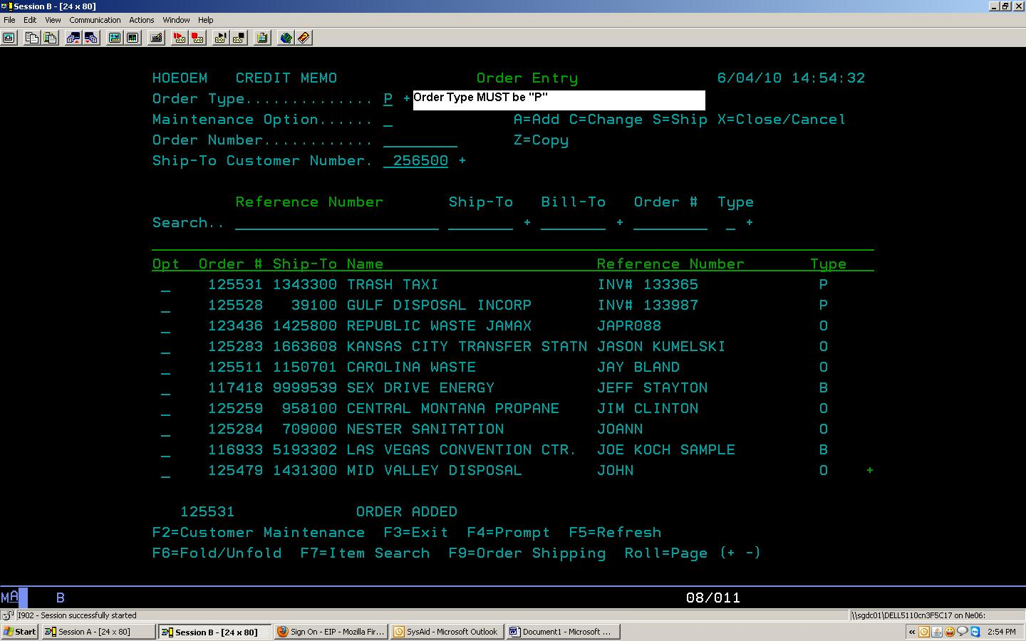

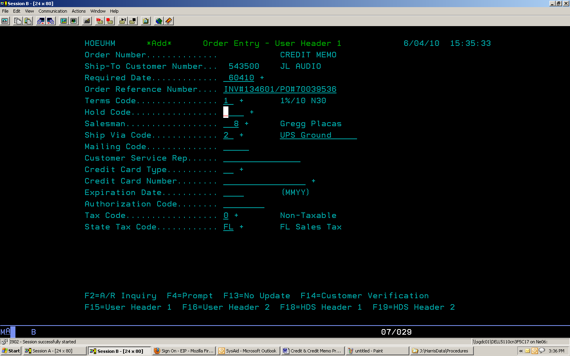

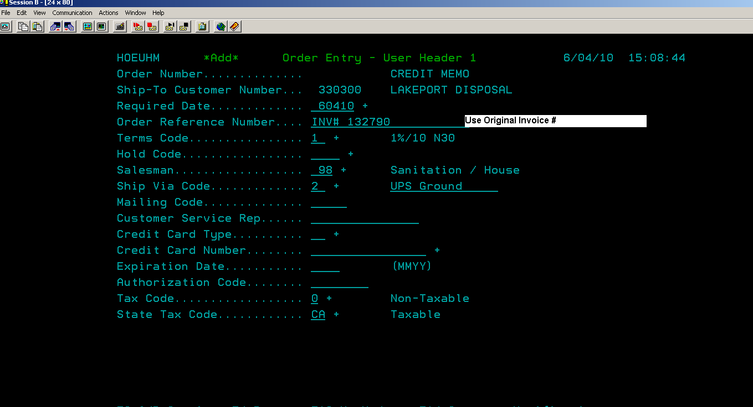

Materials Energy Surcharge Details:
Item Number must be exact to avoid paying/retracting commissions on this item. 